Game Design Document

Fill up the following document

1. Write the title of your project.

The Dream.

1. What is the goal of the game?

The goal is that to win the match and wake up early to go to school.

1. Write a brief story of your game.

This game is about a child who is sleeping and dreaming that he is in a match and playing the match. When he wins his dream finishes and he woke up early to go to his school on time. If he don’t win’s the match he don’t wake up early and he gets late for the school and wiil be scolded by his Mom.

That is the story. After little time i will try to add more things to this game like the boy is not good if a girl plays then it is not a good sense that only the boy is there so i will add girl also to this game.

1. Which are the playing characters of this game?

* Playing characters are the ones who respond to the user based on the input from the user.
* Cars, monkeys, dinos, wizards, etc., are the playing characters in the game.

|  |  |  |
| --- | --- | --- |
| Number | Character Name | What can this character do? |
| 1 | The boy sitting on the left tower | They can destroy NPC’s to defend their tower |
| 2 | The boy sitting on the right tower | They can destroy NPC’s to defend their tower |
| 3 |  |  |
| 4 |  |  |
| 5 |  |  |
| 6 |  |  |
| 7 |  |  |
| 8 |  |  |

1. Which are the Non-Playing Characters of this game?

* Non-Playing characters are the ones that don't have an action or behavior when the user interacts with the game.
* Hurdles, stones, bananas, coins, etc., are non-playing characters in the game.

|  |  |  |
| --- | --- | --- |
| Number | Character Name | What can this character do? |
| 1 | bike | Attack the opposite tower if they reach the tower |
| 2 | car | Attack the opposite tower if they reach the tower |
| 3 | truck | Attack the opposite tower if they reach the tower |
| 4 |  |  |
| 5 |  |  |
| 6 |  |  |
| 7 |  |  |
| 8 |  |  |

Draw your imagination of this game. What does this game look like?

* Draw the game either on your computer or on paper.
* Add images of the game scenes to show each of the playing and non-playing characters at least once.

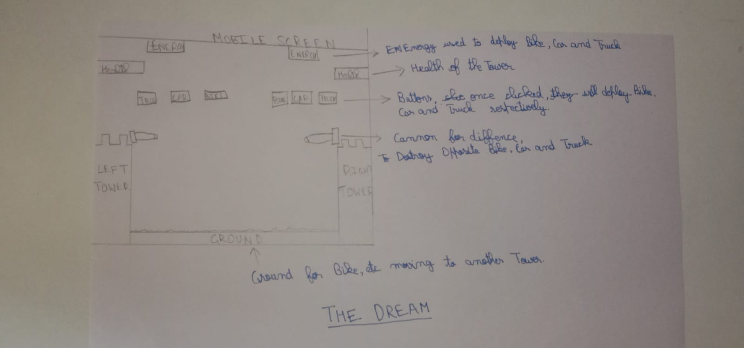

How do you plan to make your game engaging?

I made the game at a dream of a child who is dreaming that he is playing the game and if he wins then he will get up early and go to school. And if not then game is over and he will get scolded by his mom. So next time to play little brave so that the player wins then he will be happy that he was successful to help the child to get up early and the child will no tget any scolding from his mom.